**Visual Design:**

The structure of source code of any webpage defines the design and content of page allowing the information to be easily published. The visual design of Stardom.co.nz is flexible and it can be viewed easily in multiple resolution and screens. The Stardom Website has static background which is a picture of Galaxy. As Stardom is Observatory and Planetarium, the background follows the subject and it gives visitor an ambience of being in sky surrounded by stars. 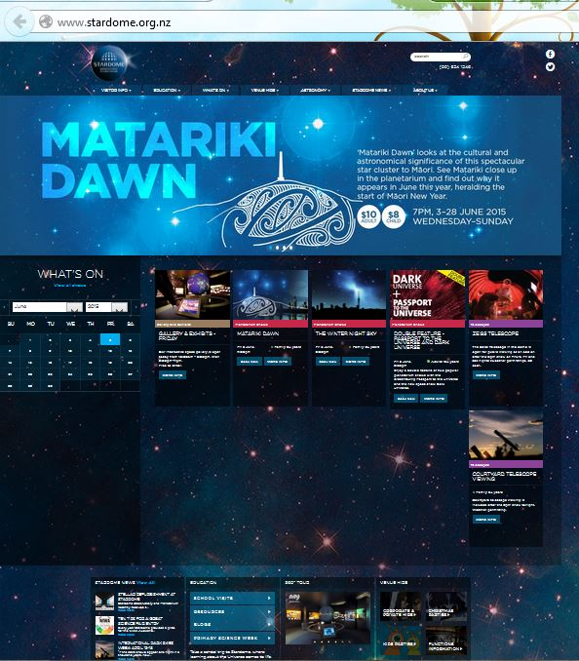

The Visual design of Stardom’s website is the result of good and intelligent use of CSS and Javascripts. Graphics, text and colours are wisely amalgamated to form an engaging and attractive website.

The website is abiding by the principles of design. The contrast is maintained perfectly in the design it helps different design elements stand out. The Base colour of the website is blue, so to make the text clearly visible the web developer of Stardom has used white colour. The Font used in the Website is Gotham SSm A and B.

The good balance of image and text has made the images self-explanatory.

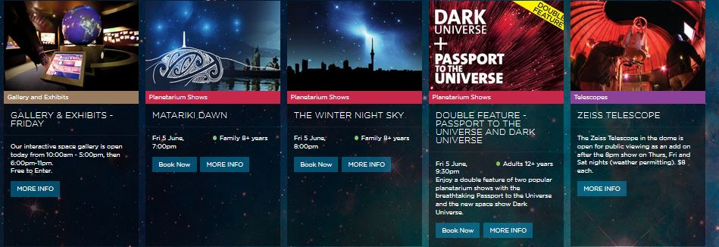

Now as far as consistency is concerned the design is consistent in colour, design, font throughout the main page and all the following pages.

All the element are placed close to each other. The page has many different element but still the whole visual looks one. All the information related to any particular vent is grouped together.

All pages were found to include a meta description. This is good because search engines (like Google) show this text in search result pages.

## Multimedia Elements

Multimedia is using images, sound, video and other media together and presenting information in a single presentation.

Images:

This website is full of images as it is a Planetarium website. So everything is depicted in combination of image and related text. The main page alone contains 27 images.

The two prominent image formats used in stardom website are jpg and png.

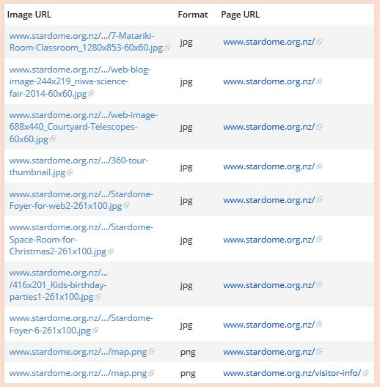

These two formats are web-friendly format.

But on inspecting the html source code of the website I found that web developer of Stardom has not defined the image size attributes which will increase the page loading time.

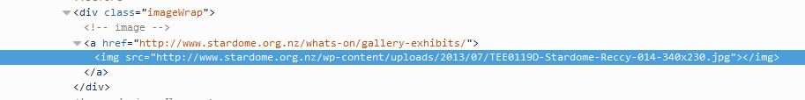

Slide Show:

The Slide Show comes second from top after the main menu. I must say using slider for upcoming events is very impressively. The colour, Image and text combination is putting life in each and every individual event listing. It is very engaging. 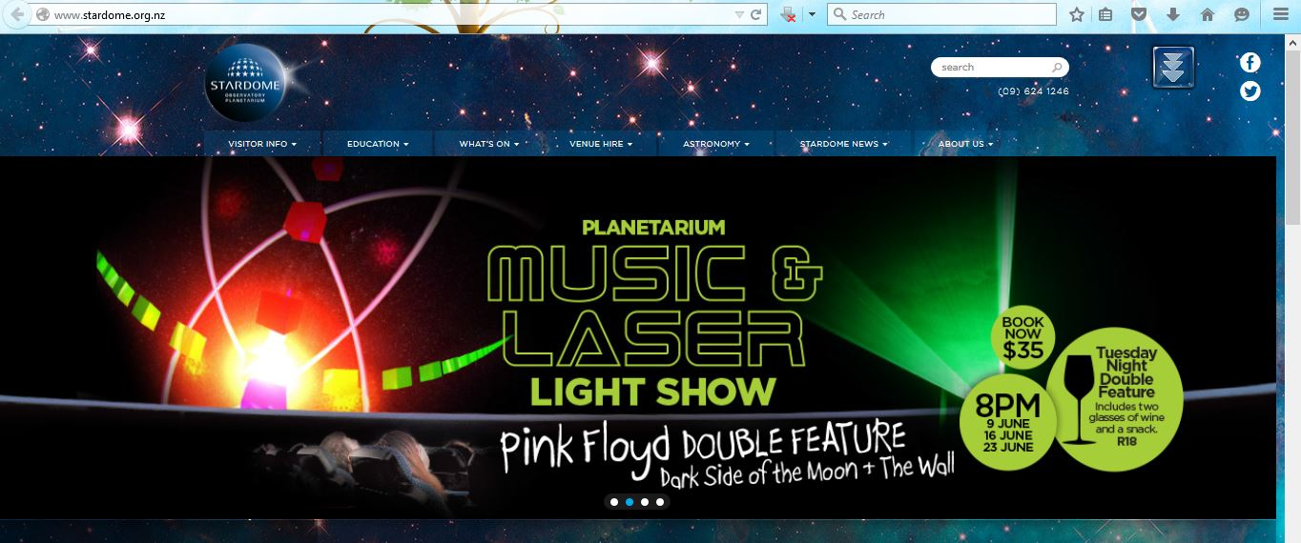

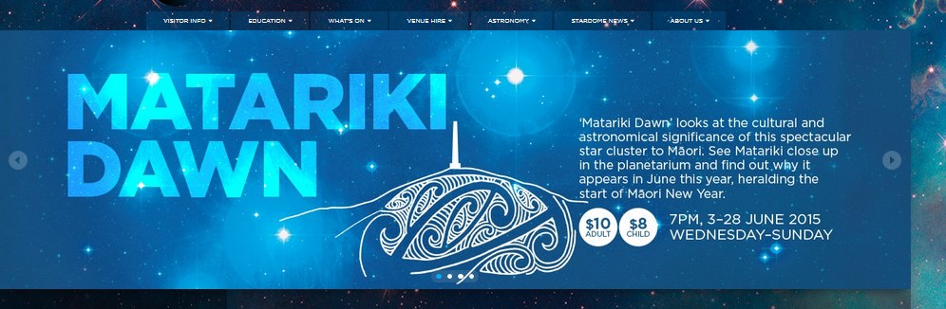

360 view:

360 view are very useful for advertising such places. It gives a taste of what visitor can expect on visiting the place. It serves as virtual tour to the Planetarium which is impressive and leaves the viewer curious and fascinated about the place.

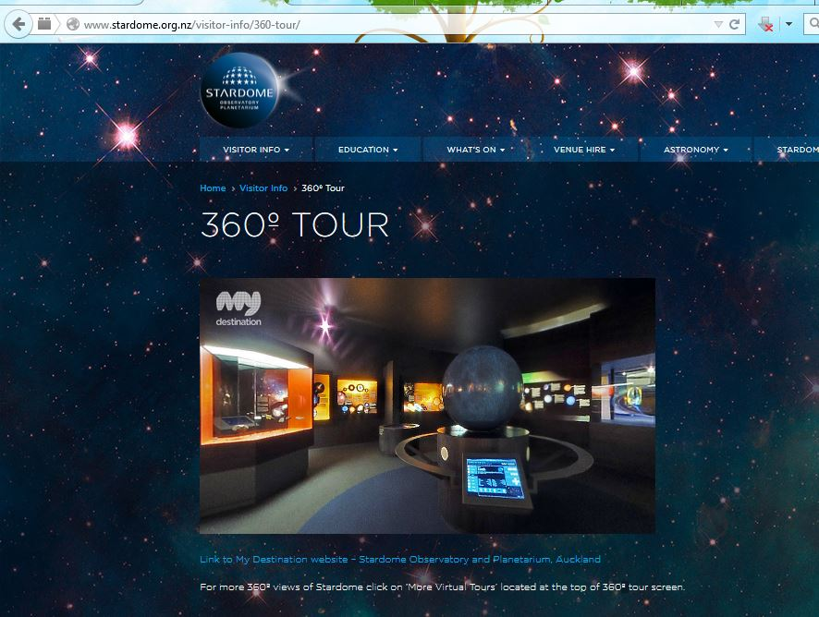

Sound, Animation and Video:

I could find any sound, animation or video on the website. But the use of sound or video is experience enhancing step which is missing in this website.

Ad Banners:

As this website is owned by the Auckland Council, I didn’t find any ad banner on the website.

## Navigation

Desktop

The navigation in stardom’s website is user centric and it is easily accessible to user. User doesn’t need to hunt for the content through a maze.

The menu bar is having drop down navigator.

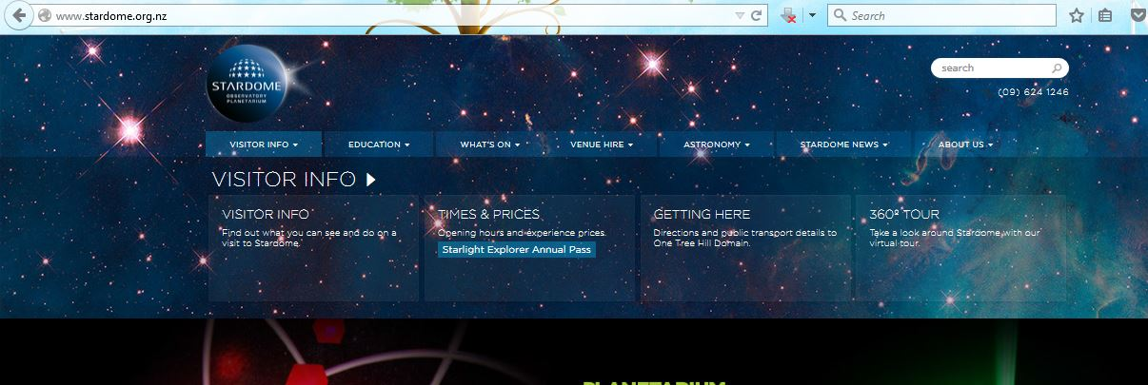

Content in Stardom’s website is well grouped. The user can easily find way to the required information. The links are self-explanatory and each link is supported by a brief information about what user can get on following that link.

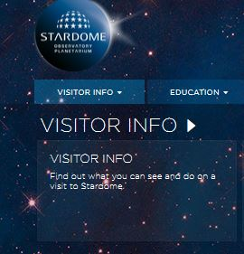

Mobile Devices:

The Website is designed in such a way that mobile users will also not find any difficulty to reach out to any information.

As shown in the pictures below. The web developing has made best effort to make navigation user friendly.

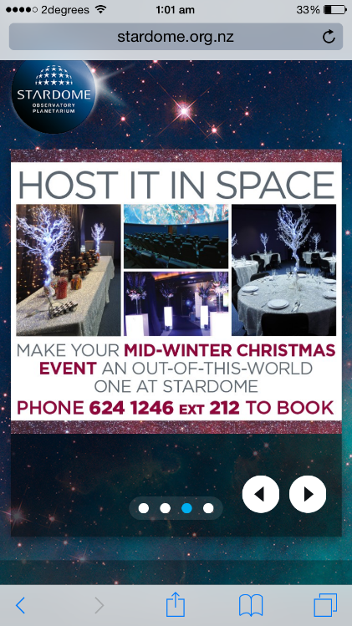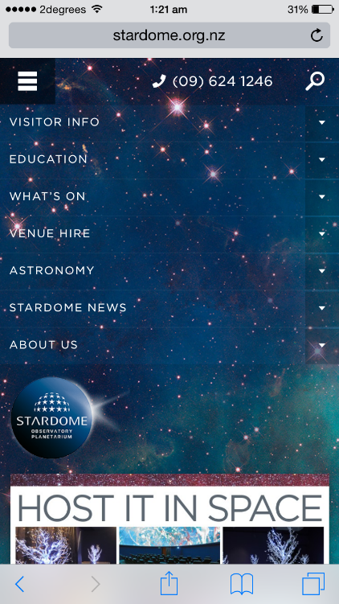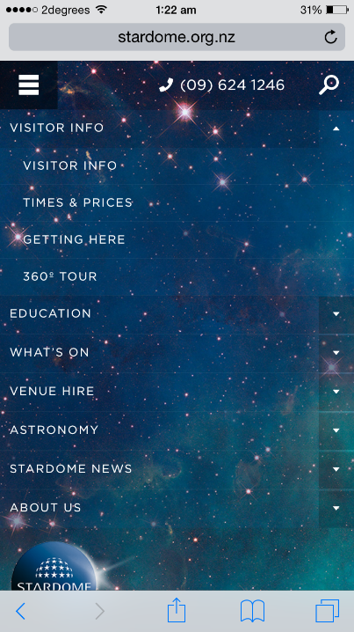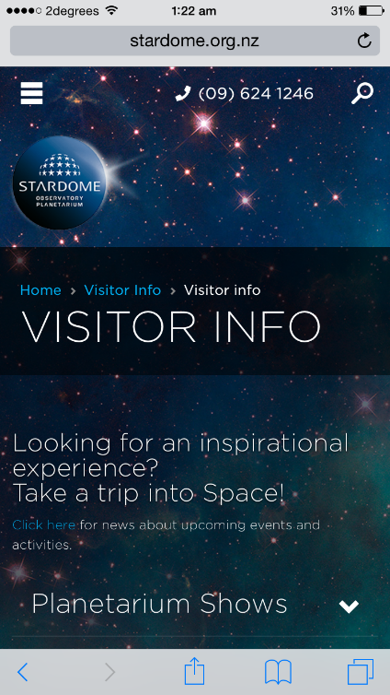

## Usability and Accessibility

Accessibility test EvalAccess shows following results:

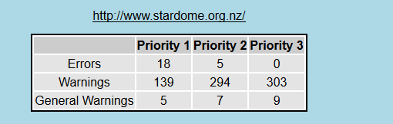

It shows this website is full of warnings. There are 18 Priority 1 error and 5 Priority 2.

I tried to get results from WAVE but for some reasons which were beyond my explanation I couldn’t get it.

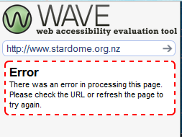

Site Popularity and SEO

One of the online Websites ranking website suggests Stardom.org.nz is the 1,693,063rd most popular website in the world.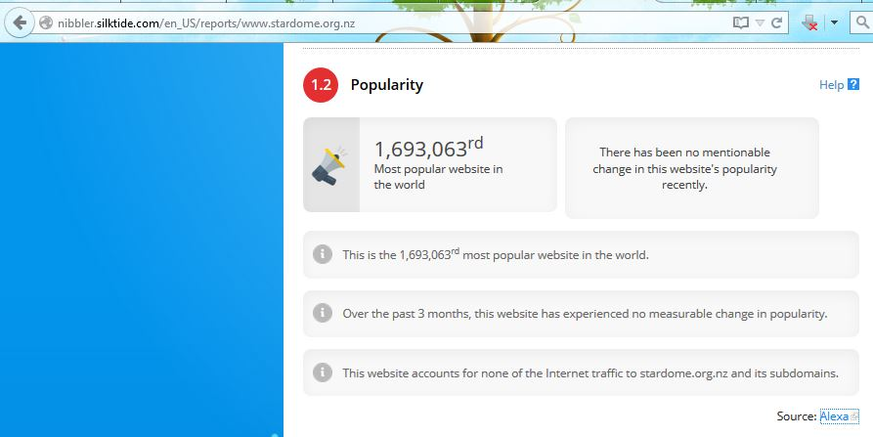

Source: <http://nibbler.silktide.com/en_US/reports/www.stardome.org.nz>

Google search listing:

All the pages in of Stardom.org.nz are found to include meta description. This is good because search engines (like Google) show this text in search result pages.

This is how this website will look in Google search listings:

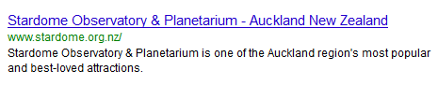

## Ownership and Copyright

Stardom has implemented the Copyright symbol at the footer of the website.

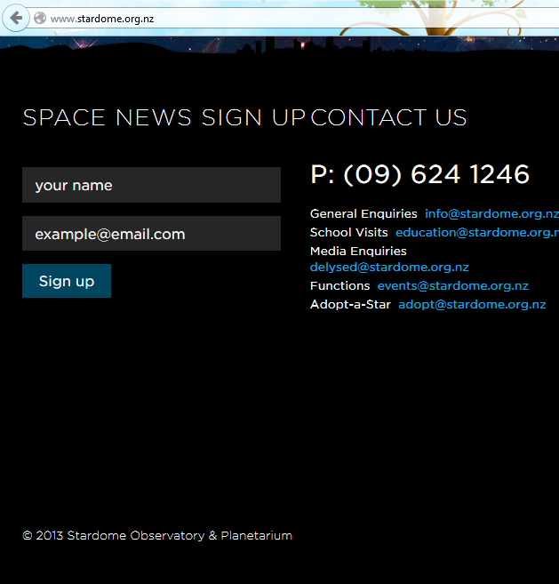

The copyright symbol © means that an author retains ownership of that work unless he gives written permission for someone else to use the work or take the copyright. Any reproduction, distribution, performance or public display of the work without permission is an infringement of the copyright.

## Technique Details

From www.netcraft .com I came to know that the website is running on Windows Server 2003 OS and web server is Microsoft IIS/6

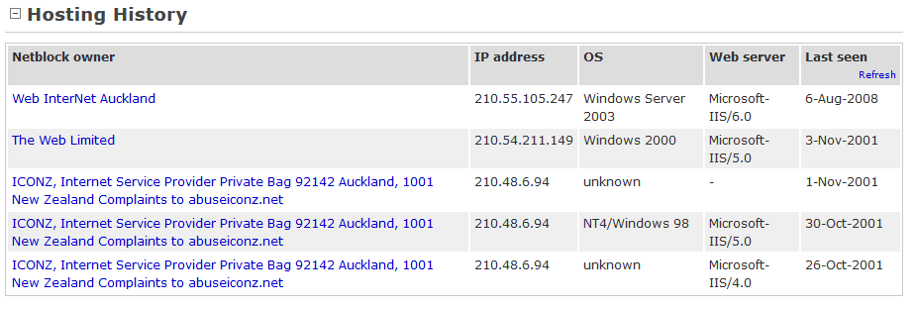

Doctype:

This website has a HTML doctype declaration. This is very essential for proper rendering and proper functioning of the webpage in compliant browsers.

Javascript and CSS:

JS and CSS are widely used in this website.

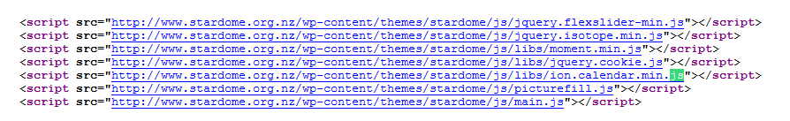

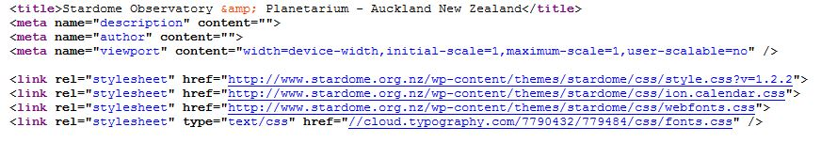

Meta Tags:

Metadata has great value, particularly to search engines. Correct use of metadata can improve your placement in search engines, but more importantly how your website appears when in a search engine. In particular, the description meta tag, is frequently shown in Google beneath the link to a specific result.

On investigating the HTML Source of the Website, I found that all pages are having meta description.



Printability:

All the pages of Stardom.org.nz are optimized for printing using CSS.

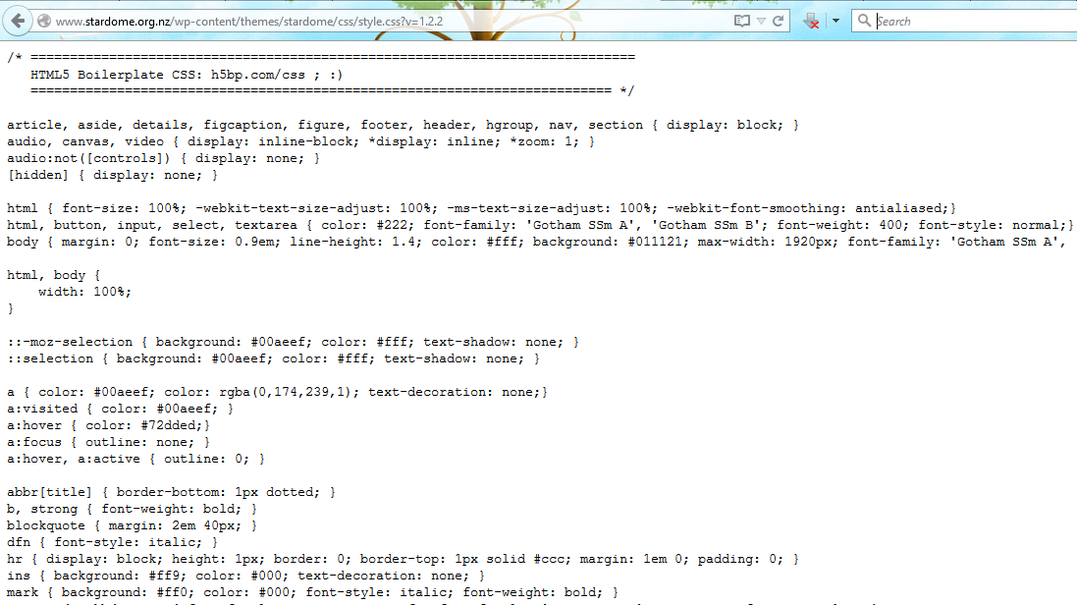

## Improvements and Highlights

***Visual Design:***

The visual design of the website id very impressive and engaging. The balance Graphics and text is wisely maintained. The Website can be easily viewed in multiple screen resolutions.

***Audio & Video:***

There is no audio or video in website, I think being a Observatory and planetarium Audio-Video will leave long lasting impression on the viewers.

***Overuse of Images:***

On Main page there are 24 images, this will increase the web page opening delay. Most of the images are in jpg format. To achieve smaller image sizes , png format can be used instead of jpg.

Also by combining 2 or more images the count of images can be decreased.

## Meta tags

All the pages are having meta description. This is good because search engines show this text in search result pages.

**Image Size Attributes:**

The Image definition in HTML source file doesn’t include image width and height attributes which can create accessibility issues for the visitors and can increase the page load time. By including the image height and width the rendering time can be saved.

**No Site Map:**

Stardom’s website has no site map present. It will make navigation even easier for those who are looking for specific information.

***Blank Space:***

When viewed on desktop, the website shows blank space in second section of the page.I think blank space can be easily minimised by re arranging or changing the size of multimedia elements in this section. 